**BAIT1013 Introduction to Computer Networks Tutorial 4: Data Link Layer (OSI Model)** 

Q1. (a) Give a term that related to upper sublayer of layer two and briefly describe that term. (3 marks)

LLC sublayer

▪ takes the network protocol data, which is typically an IPv4 or IPv6 packet, and adds Layer 2 control

information to help deliver the packet to the destination node.

MAC Sublayer

▪ controls the NIC and other hardware that is responsible for sending and receiving data on the wired or

wireless LAN/MAN medium and provides data encapsulation.

(b) The following figure shows a frame of data link layer.

Figure 1: A structure of a frame

(i) Identify a header of a frame that labeled as “A” from Figure 1 and state the function of that flag. (2 marks)

Frame start : used to identify the beginning of the frame.

(ii) Based on Figure 1, identify a frame trailer that had indicated as “B”. List a role of that flag. (2marks)

Error detection : included after the data to form the trailer

(c) Protocol Data Unit (PDU) of a message in Data Link Layer is called frame. A frame consists of three portions. There are referred to header, data and trailer.

(i) Identify a sublayer of Data Link Layer that defines the media access processes performed by the hardware. (1 mark)

MAC Sublayer

(ii) Identify and briefly describe **TWO (2)** fields that related to the header of a frame. (6marks)

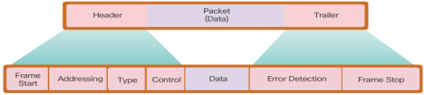(iii) What is the purpose of stop frame that located at the trailer of a frame? (2 marks)

Provides importance delimiters to identify fields within a frame

1 ***updated by Sangeetha V Feb 2024***

**BAIT1013 Introduction to Computer Networks Tutorial 4: Data Link Layer (OSI Model)** 

Q2. (a) The Figure 2 shows a network topology on how computers can communicate across LAN and WAN via different types of physical media and Layer 2 protocols. Answer the following question based on the Figure 2.

A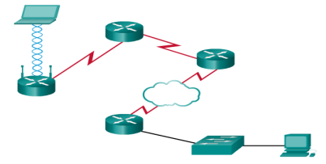

PPP

HDLC

Frame Relay B

Figure 2

(i) “A” and “B” are two different popular network connection methods for LAN. Identify the type of connecting media and the IEEE Networking Standard of LAN “A” and “B” respectively. (4 marks)

| **Label** | **Connecting media** | **IEEE Networking Standard** |
| --- | --- | --- |
| **A** | **Wireless connection / electromagnetic wave** | **WLAN IEEE 802.11** |
| **B** | **UTP cable / copper cable** | **Ethernet IEEE 802.3** |

(ii) There are two types of access method in LAN topology. Which access method is used for both “A” and “B”? (1 mark)

Contention-based access

(b) If the data link layer didn’t exist, what changes would be required of a network layer protocol such as Internet Protocol (IP)? (6 marks)

* IP would handle both addressing and routing, absorbing functions from MAC addresses.
* It would add frame formatting tasks, such as headers and trailers.
* IP might integrate error detection and correction mechanisms.
* Flow control and congestion management would be managed on a larger scale.
* Medium access control would become part of IP's responsibilities.
* IP and other protocols would need significant adaptation for reliable transmission without the data link layer.

(Mac address able to locate the physical location of end advice. IP might integrate error detection and correction mechanisms.

Encapsulate the data into a frame and pass it to the next layer)

2 ***updated by Sangeetha V Feb 2024***

**BAIT1013 Introduction to Computer Networks Tutorial 4: Data Link Layer (OSI Model)** 

Q3. ***ExamQustion***

(a) A junior engineer is discussing the media access method for a wireless network. He says “Token passing is the method used to manage controlled-based access on a wireless network”. Do you agree with the statement? Discuss your view.

I do not agree with the statement. CSMA/CA is the method used to manage contention-based access on a wireless network. Characteristics of CSMA/CA include stations can transmit any time, collision exist and there are mechanism to resolve contention for the media.

(8 marks)

(b) One of the functions of the network layer in the Open Systems Interconnection (OSI) model is encapsulating the packet. Describe the process of encapsulation when the network layer receives the Protocol Data Unit (PDU) from the layer above.

.

Receive Segment from layer above. At the network layer, the packet will encapsulate with the layer 3 header and forward to the data link layer. At the data link, the frame will encapsulate with the layer 2 header.

(4 marks)

*(past year question Feb 2023)*

(c) Discuss the following terms with a support of a diagram.

i) Half-duplex

ii) Full-duplex

Half Duplex

• Both devices can transmit and receive on the media but cannot do so simultaneously.

• WLANs and legacy bus topologies with Ethernet hubs use the half-duplex mode.

• Half-duplex allows only one device to send or receive at a time on the shared medium.

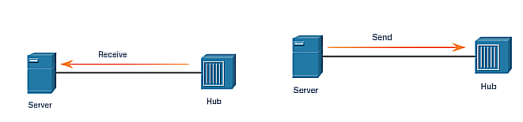

Full Duplex

• Both devices can simultaneously transmit and receive on the shared media.

• The data link layer assumes that the media is available for transmission for both nodes at any time

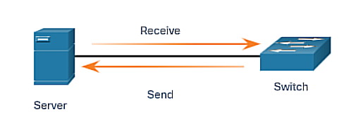

(8 marks)

3 ***updated by Sangeetha V Feb 2024***